Table of Contents

Table of Figures 1

2.0. Literature Review 2

2.1 Introduction: 2

2.2 Wireless Network: 2

2.3 Raspberry Pi: 3

2.4 Drones with Ip networks: 4

2.5 Drones local and foreign rights 7

2.6 conclusion 7

Figure 1 - Drone(UAV) 4

# 2.0. Literature Review

# 2.1 Introduction:

There is a growing number of papers related to the integration of drones and networks discussing drone-BS placement, various use-cases, design and management challenges. This chapter consists of four main sections which then will be split into further sub-sections. In the first section, I will be discussing the mechanisms of Wireless network. In the second section, I will be discussing the basics of the Raspberry Pi device. The third section will consist of discussing how Several studies identified the benefits of aerial platforms to support wireless communications in emergency situations. The last section will be discussing the local and foreign rights of how these can affect my work.

# 2.2 Wireless Network:

Over the decade the use of computers and other network devices has highly increased and become more dependent on. The network first started with having users directly connected with physical cables which, their movement is reduced dramatically. However, when wireless connectivity was released this poses no such restriction and allowed more movement on the user's part. This means that by connecting users to a wireless network, they will be allowed to communicate together with a great deal of movement. Additionally, wireless networks can provide interconnection between different devices. They can offer numerous benefits over a wired network because of features such as mobility, scalability, and ease of installation.

M.Kane(2016) stated that network connectivity has come to be considered essential futility. There is not only a growing number of devices (e.g., smartphones, bracelets, wearables, different-nature sensors, etc.) that need to be almost continuously connected because of the advent of the Internet of Things (IoT) paradigm but societal changes are also posing new challenges into the telecommunications arena. As a surprising example, it has been recently published in the news the need for Internet access that refugees request when they get to the refugees’ camps. Among their first questions asked when they arrive was “when will we get WIFI?”, and far from frivolous, this is a need for them as important as being fed.

Over the years, the wireless network field underwent improvements as time passed, There are different types of wireless networks, including wireless LAN, wireless MAN, wireless PAN, and wireless WAN. These wireless networks are all dependent on a different geographical area. Also, a set of standards using the 802.11 protocol has been created to develop wireless computer communication on different frequency bands. These standards were created by the IEE committee in 1997 and updated in 1999. Different standards include 802.11a, 802.11b, 802.11n, 802.11g, and 802.11 ac.

The 802.11g and 802.11a both uses the same types of modulation techniques. This first technique which is used by both of these protocols is the Orthogonal Frequency Division Multiplexing(OFDM) which works with data rates of 6, 9, 12, 18, 24, 36, 48, and 54 Mbit/s, The Orthogonal frequency division multiplexing (OFDM) is a modulation and multiplexing technique. Modulation is the process of how data is encoded onto a carrier signal, which is then amplified and applied to an antenna. Multiplexing is the process of having one transmission channel used for multiple signals. OFDM has gained popularity in several applications including digital subscriber loops, WIFI networks. It is also a strong contender for fourth generation cellular land mobile radio systems. OFDM transmits data in parallel by modulating a set of orthogonal sub-carriers. OFDM is popular because it provides relatively easy solutions to some difficult challenges that are encountered when using single-carrier modulation schemes on wireless channels. Simplified frequency domain equalization is often touted as a primary advantage of OFDM over single-carrier modulation with conventional time-domain equalization. However, frequency domain equalization can be applied just as easily to single-carrier modulation techniques as it can to OFDM. Perhaps the greatest benefit of using OFDM is that the modulation of closely spaced orthogonal sub-carriers partitions the available bandwidth into a collection of narrow sub-bands. Motivated by the water-pouring capacity of a frequency selective channel, adaptive trans-mission techniques can be readily used to increase the overall bandwidth efficiency.

The Direct-Sequence Spread Spectrum (DSSS) modulation schemes is the second modulation technique used by the two protocols. Direct sequence spread spectrum is a spread spectrum modulation technique which is a form of transmission that looks very similar to white noise over the bandwidth of the transmission. However once received and processed with the correct descrambling codes, it is possible to extract the required data.

When transmitting a DSSS spread spectrum signal, the required data signal is multiplied with pseudo random noise spreading code what is known as a spreading or chip code data stream. The resulting data stream has a higher data rate than the data itself. Often the data is multiplied using the XOR (exclusive OR) function.

The baseband data stream is then modulated onto a carrier and in this way the overall signal can be spread over a much wider bandwidth than if the data had been simply modulated onto the carrier. This is because, signals with high data rates generally occupy wider signal bandwidths than those with low data rates.

To decode the signal and obtain the original data, First the CDMA signal is demodulated from the carrier to restore the high-speed data stream. This is then multiplied with the spreading code to regenerate the original data. When this is done, only the data that was generated with the same spreading code is regenerated, the rest of the other data that is generated from different spreading code streams is ignored.

The use of direct sequence spread spectrum is a powerful principle and has many advantages as significantly improves protection against interfering (or jamming) signals, especially narrowband and makes the signal less noticeable. It also provides security of transmission if the code is not known to the public. These reasons make DSSS very popular by the military. In fact, DSSS was first used in the 1940s by the military.

These protocols also employ the single input, single output (SISO) antenna technologies. The SISO (single input, single output) refers to a wireless communications system in which only one [antenna](https://searchmobilecomputing.techtarget.com/definition/antenna) is used at the source (transmitter) and one antenna is used at the destination (receiver).SISO is the simplest antenna technology out of the 4 types that exists (SISO, SIMO, MISO, MIMO). In some of the environments, The SISO antenna systems are the most vulnerable to problems that are caused by multipath effects. This happens when an electromagnetic field (EM field) meets with obstructions such as hills, canyons, buildings, and utility wires, the wave fronts are scattered, thus they take many different paths to reach the destination. The late arrival of the scattered portions of the signal causes some problems such as fading, cut-out (cliff effect), and intermittent reception (picket fencing). In the digital communications system, it can cause a reduction in data speed and an increase in the number of errors.

# 2.3 Raspberry Pi:

The Raspberry Pi is a low cost, credit-card sized micro-computer that plugs into a computer monitor or TV and uses a standard keyboard and mouse just like a regular computer. The start of the Raspberry Pi was a non-profit venture, whose founders were mostly part of Cambridge's thriving technology sector. Their hope was that teachers, developers, and the government would come together to get the device into the hands of children to aspire them in the world of programming. It runs with the Python programming language and is a great way to learn about hardware hacking and coding. (Cellan-Jones, Rory,2011)

Despite this newer versions of the RPI have been announced over the years which has become more advanced to where It’s capable of doing everything you would expect a desktop computer to do, from browsing the internet and playing high-definition video, to making spreadsheets, word-processing, and playing games. The latest versions of the micro-computer have also wireless network built it, this allows the Raspberry Pi the ability to interact with the outside world and has been used in a wide array of digital maker projects, from music machines and parent detectors to NASA’s Open source rover.

# 2.4 Drones with Ip networks:

Recently, the remote-controlled **unmanned aerial vehicle** (**UAV**) commonly known as drones are rapidly spread over the whole world in figure 1. Drones consist of multi-propeller, and so it is easy to control the body in the air. Also, with the recent development of the M2M (machine to machine) technology, some drones consist of the wireless IP network, GPS, and cameras. Thus, they can be controlled by mobile PC or smartphones for the purpose of not only hobbies but also surveillance systems or ad-hoc networks.

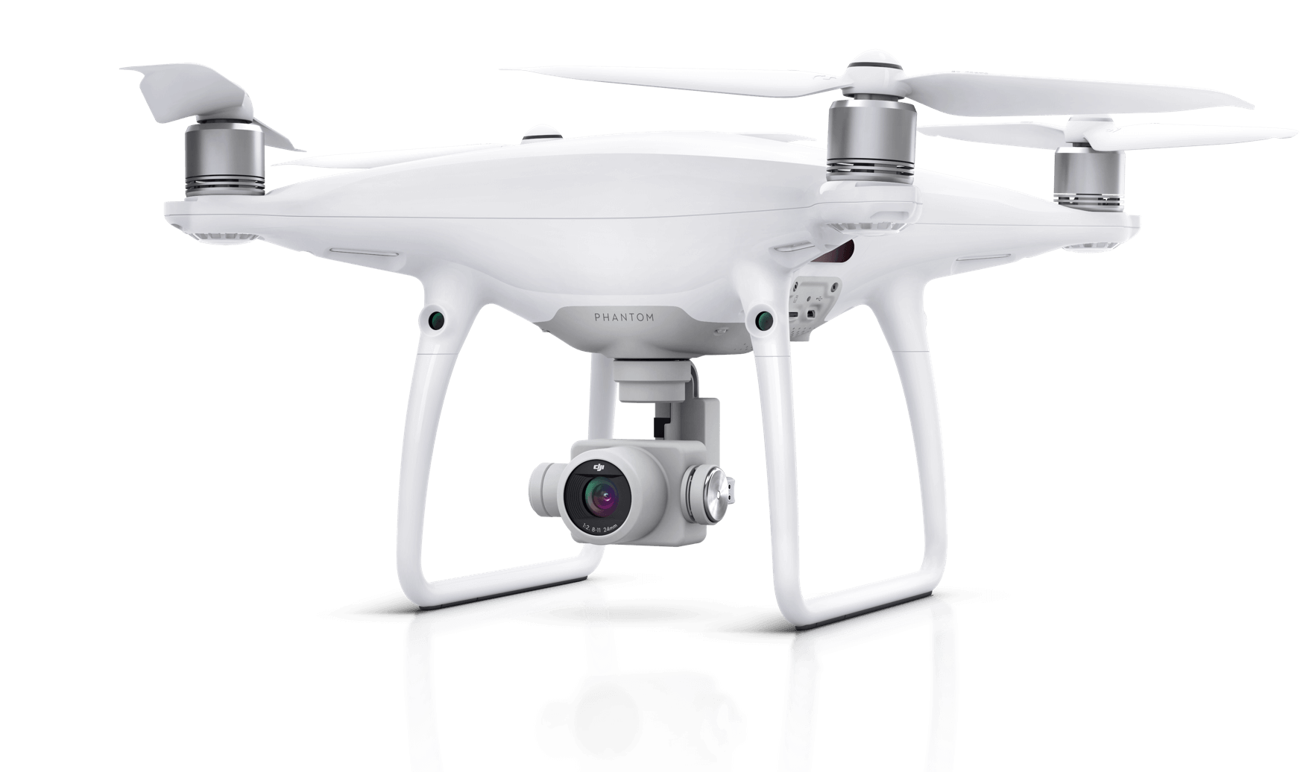

Figure 1 - Drone(UAV)

Focusing on drone communications, UAV’s have been used to deploy air networks in different fields of action, N. Uchida et al (2014) introduced a so-called Autonomous Flight Wireless Node(AFW) which supports DTN routings for the Disaster Information System (DIS) In the proposed system, the drone with wireless interfaces is applied, and it actively supports the proposed DTN routings for the Disaster Information System (DIS). That is, the AFW automatically flies for seeking possible wireless nodes, send and receive disaster information by the proposed DTN routings, and return to the possible stations that wireless charge units are equipped when the battery needs to charge. Despite this, the results identified that some considerable improvements would need to be carried out in future studies. Highlighting the most important, the effect of the winds and the avoidance of obstacles such as trees or buildings.

In addition to the work done earlier, N. Uchida et al (2015) have also expanded the idea and considered the use of drones with Wi-Fi to form An Autonomous Flight Wireless Nodes (AFW) that presents a Resilient Network. This was concluded using the same method as discussed earlier, Delay Tolerant Networks (DTN) combined with Never Die Networks(NDN) was proposed. The setup aimed to communicate with isolated areas. However, their drawback of this implementation involves a moving drone in very low altitudes and needs to be nearby of any client to collect data.

Similarly, several initiatives have been announced using UAV to provide broadband connectivity. For instance, the European projects ABSOLUTE, ANCHORS, and AVIGLE. When a UAV is exploited with this aim, the term Low Altitude Platform (LAP) can be also employed.

The work done by (J. Sae et al (*2016)* studied the coverage of temporary WiFi networks built using drones as access points. The authors studied the coverage aspects of a low altitude platform (LAP) system that can form a temporary communication network. The system consists of multiple autonomous drones equipped with dual-band Wi-Fi access points (APs) with ad hoc capabilities to form a mesh network. During this study, the researchers only used computer simulation to theoretically evaluate the coverage area by applying a deterministic radio propagation model called the Dominant Path Prediction Model. The lack of experimental results in this study is a notable shortcoming since their results will likely not correspond entirely with real-life implementations although the utilized models are rather accurate as stated by the researchers.

Similar to J. Sae et al (2016) the authors H. Hariyanto et al (2009) also have presented the idea of providing emergency broadband coverage with the utilization of LAPs. Their idea is based on utilizing a simple tethered balloon, flying at a maximum altitude of 440 m, can carry an IEEE 802.11a/g payload, and cover an area of about 72 km2. Naturally, in these cases, the covered area and maximum system throughput are relatively limited and only LOS communications are supported.

A. Guillen-Perez et al (2016) noted that an interesting strategy to extend the capacity of wireless coverage can also be archived by the use of light development boards. To do so, an Intel Galileo development board was used and appropriately configured and equipped as a WIFI node playing either the role of an access point in the infrastructure mode or of an intermediate hop in the ad-hoc operational mode. This device was then integrated onboard a drone. During this research, they compared both WIFI modes in terms of coverage area, throughput, and energy efficiency which the results revealed better performance of the infrastructure mode regarding received signal strength and bandwidth, but a worse behaviour in terms of current consumption compared with the ad-hoc mode.

The trend of mixing cellular communications with UAV networks to extend connectivity has been also recently addressed by A. Merwaday et al (2015). They proposed to transform the UAV into a 5G base station, Through simulations, they analysed the throughput gains that were be obtained by exploiting the mobility feature of the UAVs. Their simulation results show that when there is the loss of network infrastructure, and that the deployment of UABSs at optimized locations can improve the throughput coverage and the 5th percentile spectral efficiency of the network.

For example, Segor et al.(2010) proposed mobile ground control station for local surveillance by using drones with IP networks, and Baseca et al.in “Communication Ad Hoc Protocol for Intelligent Video Sensing using AR Drones", introduced the communication ad-hoc protocol for HD video transfer with drones and smartphones.

The conference done by Kalantari et al (2016) states that Using drone base stations (drone-BSs) in wireless networks has started attracting attention. Drone-BSs can assist the ground BSs in both capacity and coverage enhancement” A proposed method of using a heuristic algorithm to find the positions of drone-BSs in an area with different user densities was used. The goal of this conference was to find the minimum number of drone-BSs and their 3D placement so that all the users are served.

Antonio Guillen-Perez et al (2016) emphasised the idea of Extending the capacity or coverage of wireless systems through the deployment of aerial communication networks To do so, an Intel Galileo development board was appropriately configured and equipped as a WIFI node playing either the role of an access point in the infrastructure mode or of an intermediate hop in the ad-hoc operational mode. This device was then integrated onboard a drone. A comparison of both WIFI modes was conducted in terms of coverage area, throughput, and energy efficiency. Preliminary results reveal that there is a trade-off between

# 2.5 Drones local and foreign rights

Drones are mostly seen to be as toys by some before using a drone and taking it out for a test flight it is important to be aware of any rules and regulations that may apply when flying such devices. In Malta, there are currently no specific laws geared to operate drones. Furthermore, there is also the complicating fact that Malta is entirely within the controlled airspace. Because of this, Malta is in a unique situation. In contrast to most other European countries, Malta permits the operation of drones in controlled airspace.

Currently, all drones must be approved and registered by the *Civil Aviation Directorate (CAD)* only if the drone weighs more than 250 grams. It is important to follow the local rights as they might differ from other countries/cities. Failure to register an unmanned aircraft that is required to be registered may result in regulatory and criminal penalties.

General rules which apply worldwide are the following:

* Drones may not be flown overpopulated areas such as towns, cities, and villages; people or crowds; vehicles or vessels; or private property without the permission of the property owner.
* Drone pilots should be aware that the collection of images of identifiable individuals, even inadvertently, when using cameras mounted on small drones, may be subject to Malta’s Data Protection Act.
* Drones must give way to manned aircraft in all instances.

# 2.6 conclusion

In this chapter, an overview of wireless networks was discussed along with the types of networks. The history and uses of the Raspberry Pi device were also discussed. In this thesis, the objective is to extend a network with the use of a Raspberry Pi, performs tests, and collect results to identify whether such a proposed device would be benefit able.

References

* Cellan-Jones, Rory (2011). ["A£15 computer to inspire young programmers"](http://www.bbc.co.uk/blogs/thereporters/rorycellanjones/2011/05/a_15_computer_to_inspire_young.html). BBC News.
* Raspberry Pi. (2020). What Is A Raspberry Pi?. [online] Available at: https://www.raspberrypi.org/help/what-%20is-a-raspberry-pi
* H. Hariyanto, H. Santoso, and A. Widiawan, “Emergency broadband access network using low altitude platform,”
* M. Kane, “Refugees in Greece need internet so badly that they’ll stop a riot to let the wifi guys work,” *Quartz,* *<http://qz.com/711529>*, 2016.
* J. Sae *et al*., “Coverage Aspects of Temporary LAP Network,” *Proc. 12th Annu. Conf. Wirel. On-demand* N*etw. Syst. Serv.*, pp. 100–103, 2016.
* N. Uchida, M. Kimura, T. Ishida, Y. Shibata, and N. Shiratori, “Evaluation of Wireless Network Communication by Autonomous Flight Wireless Nodes for Resilient Networks,”
* Kalantari, Elham & Yanikomeroglu, Halim & Yongacoglu, Abbas. (2016). On the Number and 3D Placement of Drone Base Stations in Wireless Cellular Networks. 1-6. 10.1109/VTCFall.2016.7881122.
* F. Segor, A. Burkle, T. Partmann,R. Schonbein. "Mobile ground control station for local surveillance", Proceedings of the 2010 Fifth International Conference on Systems (ICONS 2010), PP. 152-157, Apr 2010.
* C. C. Baseca, J. R. Diaz, J. Lloret. "Communication Ad Hoc Protocol for Intelligent Video Sensing using AR Drones", 2013 IEEE Ninth International Conference on Mobile Ad-hoc and Sensor Networks (MSN), pp. 449 - 453, Dec. 2013.
* N. Uchida, N. Kawamura, T. Ishida and Y. Shibata, "Proposal of Autonomous Flight Wireless Nodes with Delay Tolerant Networks for Disaster Use," 2014
* Merwaday and I. Guvenc, "UAV assisted heterogeneous networks for public safety communications," 2015 IEEE Wireless Communications and Networking Conference Workshops (WCNCW), New Orleans, LA, 2015
* Guillen-Perez, R. Sanchez-Iborra, M. Cano, J. C. Sanchez-Aarnoutse and J. Garcia-Haro, "WiFi networks on drones," 2016 ITU Kaleidoscope: ICTs for a Sustainable World (ITU WT), Bangkok, 2016
* notes, e., 2020. *What Is DSSS | Direct Sequence Spread Spectrum*. [online] Electronics-notes.com. Available at: https://www.electronics-notes.com/articles/radio/dsss/what-is-direct-sequence-spread-spectrum.php
* Li, Y. and Stüber, G., 2011. *Orthogonal Frequency Division Multiplexing For Wireless Communications*. New York: Springer
* Chirag R. Shah, 2017. “Performance and Comparative Analysis of SISO, SIMO, MISO, MIMO”